Project Planning Phase
Project Planning Template (Product Backlog, Sprint Planning, Stories, Story points)

Date | 26 June 2026
Team ID
Project Name | Student Leave Request Management
Maximum Marks | 5 Marks

Product Backlog, Sprint Schedule, and Estimation (4 Marks)
Sprint | Functional Requirement (Epic) | User Story Number | User Story / Task |  | Story Points | Priority | Team Members
Sprint-1 | Project Setup | USN-1 | Create scoped application, roles, Leave Request table, Student View, leave submission |  | 8 | High
Sprint-2 | Approval Workflow | USN-2 | Faculty View, Class Teacher approval, rejection, manual escalation to HOD |  | 9 | High
Sprint-3 | HOD and Notifications | USN-4 | HOD approval, modify leave days, Flow Designer, email notifications |  | 8 | Medium
Sprint-4 | Testing and Documentation | USN-5 | Testing, bug fixes, reports, final documentation, presentation |  | 5 | High

Project Tracker, Velocity & Burndown Chart: (4 Marks)
Sprint | Total Story Points | Duration | Sprint Start Date | Sprint End Date (Planned) | Story Points Completed (as on Planned End Date) | Sprint Release Date (Actual)
Sprint-1 | 8 | 2 Days | 22 June 2026 | 23 June 2026 | 8 | 23 June 2026
Sprint-2 | 9 | 2 Days | 24 June 2026 | 25 June 2026 | 9 | 25 June 2026
Sprint-3 | 8 | 2 Days | 26 June 2026 | 27 June 2026 | 8 | 27 June 2026
Sprint-4 | 5 | 1 Day | 28 June 2026 | 28 June 2026 | 5 | 28 June 2026

Velocity:

- Total Story Points: 30
- Total Duration: 7 days
Average Velocity = 30 ÷ 7 ≈ 4.3 story points/day

Burndown Chart:
A burn down chart is a graphical representation of work left to do versus time. It is often used in agile software development methodologies such as Scrum. However, burn down charts can be applied to any project containing measurable progress over time.

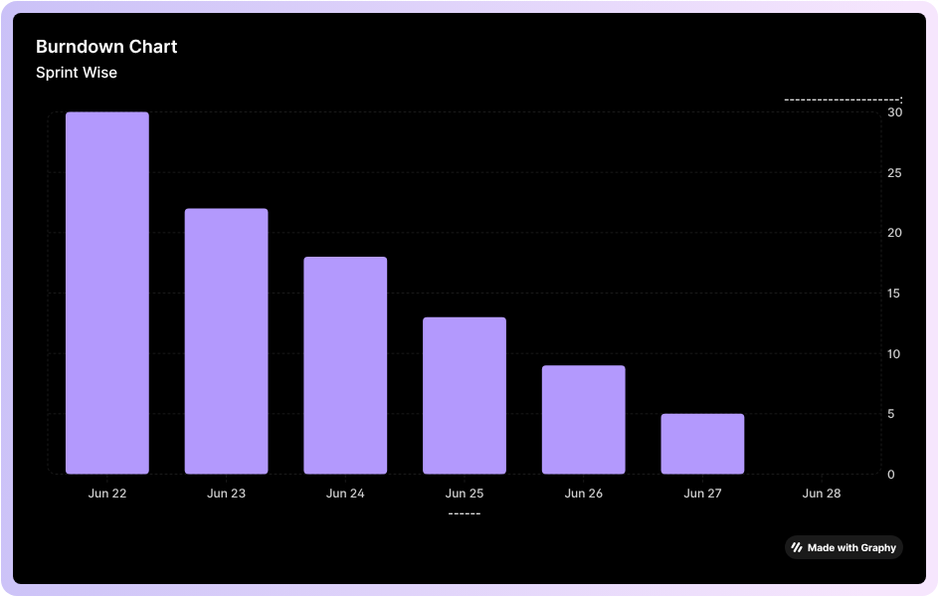

https://www.visual-paradigm.com/scrum/scrum-burndown-chart/
https://www.atlassian.com/agile/tutorials/burndown-charts

Reference:
https://www.atlassian.com/agile/project-management
https://www.atlassian.com/agile/tutorials/how-to-do-scrum-with-jira-software
https://www.atlassian.com/agile/tutorials/epics
https://www.atlassian.com/agile/tutorials/sprints
https://www.atlassian.com/agile/project-management/estimation
https://www.atlassian.com/agile/tutorials/burndown-charts

